Bahria University

Karachi Campus

**COURSE: Data Communication and Networking**

COURSE CODE: **CEN-222**

**PROJECT REPORT**

**SUBMITTED BY:**

Name and registration number:

Qaiser Abbas

Reg no: 57245

**SUBMITTED TO:**

Engr. Mahawish Fatima/ Engr. Fareeha Dilawar

**SIGNED REMARKS: SCORE:**

Contents

BACKGROUND: 3

INTRODUCTION: 4

PROJECT PARADIGM 6

MECHANISM AND WORKING: 10

FUNCTIONALITIES: 14

FUTURE WORK: 17

CONCLUSION: 18

REFERENCES: 19

# BACKGROUND:

Many of us are away from our homes throughout the day whether be it for work purpose or running errands. Some of us usually spend a day out or even leave our house unaccounted for a couple of days leaving our electronic appliances without any monitoring or control. And due to human errors, we sometimes leave devices plugged into the power sockets and some devices need to work automatically depending on the environment. All devices need individual attention time to time to operate. If some devices not operated properly could consume electricity causing higher bills or damage/ harm the room environment. So, I propose to design an internet based home automation system that will enable us to remotely manage our appliances from anywhere around the world.

Smart home is a house that uses currently released IOE technology to automate different activities of home. IOE devices connected to the internet, to allow the distant monitoring and controlling of different home appliances such as lighting, heating, cooling and alarming. In this paper, I implemented smart home using new released Cisco packet tracer simulation software, since different IOE device used for home automation is included in this new version simulator. The previous software has only networking device, but in new released simulator IOE device is included those are sensor, board, IOE device and Programming Languages with classically networking device.

To design smart home, I used different device used for home security, safety and home environment prosperity. The fulfillment of this concept requires research in the areas of low-power integrated circuits, embedded systems design, network protocols, data analytics, artificial intelligence, and control theory, among others. There has been much advancement in these areas, and the realization of IoT is becoming increasingly probable.

# INTRODUCTION:

The Home Automation is a wireless home automation system that is supposed to be implemented in existing home environments, without any changes in the infrastructure. Home Automation let the user to control the home from his or her computer and assignations that should happen depending on time or other sensor readings such as light, temperature or sound from any device in the Home Automation network

Home automation can help us:

* by remotely monitoring and controlling our appliances.
* by improving home safety
* by alerting any emergency
* by saving and utilizing proper electricity according to the requirement.

In Project done using software and hardware that is designed its performance and done testing to make the application by configuring and testing of network systems by designing the concept of smart home using the IoT home gateway as the media path that connects multiple wireless devices wirelessly and provides automatic addressing to devices connected to the home gateway, where all devices connect to the smartphone as an interface medium for controlling and monitoring electronic devices. Based on the development of smartphones today already has the presentation of advanced features and also has the ability to support the development of computer networking devices that make it a necessity in humans. For that purpose, efforts are made to increase the needs of households to facilitate the use and control of all electronic devices by using remote or remote control, where devices that can be controlled using smart home technology such as lighting devices, access door, fan and various electronic devices others that can be activated or not activated using a smartphone through the home gateway computer network.

In recent years, wireless systems like Wi-Fi have become more and more common in-home networking. Also, in home and building automation systems, the use of wireless technologies gives several advantages that could not be achieved using a wired network only. We can get:-

1) Reduced installation costs: First and foremost, installation costs are significantly reduced since no cabling is necessary. Wired solutions require cabling, where material as well as the professional laying of cables (e.g. into walls) is expensive.

2) System scalability and easy extension: Deploying a wireless network is especially advantageous when, due to new or changed requirements, extension of the network is necessary. In contrast to wired installations, in which cabling extension is tedious. This makes wireless installations a seminal investment.

3) Aesthetical benefits: Apart from covering a larger area, this attribute helps to full aesthetical requirements as well. Examples include representative buildings with all-glass architecture and historical buildings where design or conservatory reasons do not allow laying of cables.

4) Integration of mobile devices: With wireless networks, associating mobile devices such as PDAs and Smartphones with the automation system becomes possible everywhere and at any time, as a device's exact physical location is no longer crucial for a connection (as long as the device is in reach of the network).

For all these reasons, wireless technology is not only an attractive choice in renovation and refurbishment, but also for new installations.

# PROJECT PARADIGM

Sensors and components:-

|  |  |  |
| --- | --- | --- |
| No | Devices | Function |
| 01 | Router | Used to interconnect home to cellular network. |
| 02 | Cable modem | Used to connect home to the internet |
| 03 | Home gateway | Used to register smart object and give IP address to smart object |
| 04 | IOE Server | To control smart thing registered on it and provide difference server functionalities |
| 05 | Central office server | Used to connect cellular system to the router |
| 06 | Smart door | Connect to home getaway and provide Function based event |
| 07 | Cell tower | Provide cellular system coverage for home user to control the home appliance form remote |
| 08 | Smartphone | Used to control the home from outside |
| 09 | Temperature Monitor | Used to sense the temperature of the home. |
| 10 | Smart window | Used to control the window remotely Affects. When the door is opened, those gases will decrease to a maximum of 1% in total change |
| 11 | Solar Panel | To generate electricity from sun light in day time and consume it in night. |
| 12 | Power Meter | Read the power being transmitted on a line |
| 13 | Battery | Send power to other devices |
| 14 | Motor | A device that is powered by electricity to spin motor shaft. |
| 15 | Heating element | Increases the temperature by using power from battery |

**HOME GATEWAY:-**

Home Gateway have 4 Ethernet ports in addition to a wireless access point configured with the "Home Gateway" SSID (see fig 2).To secure wireless connection WEP / WPA-PSK / WPA2

enterprise can be configured on home gateway. The figure 2 shows seven internet of Things device connected to a Home Gateway by using Ethernet cable and wireless. To connect the Home Gateway to the Internet its Internet WAN Ethernet port available on home getaway. The IoE device can be remotely managed through a web interface hosted by the Home Gateway. The Home Gateway internal (LAN) IP address is 192.168.25.1 but it can also be accessed through its Internet facing IP address.

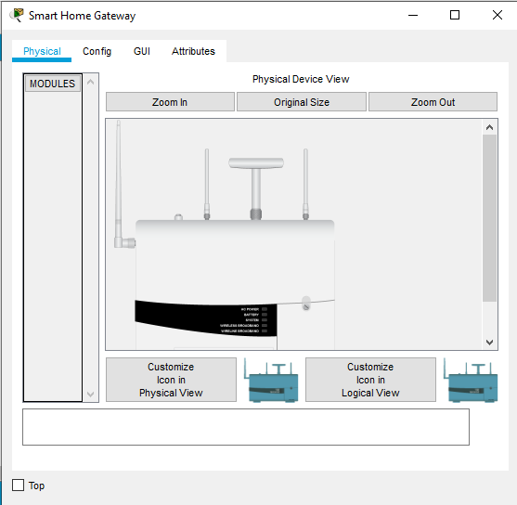

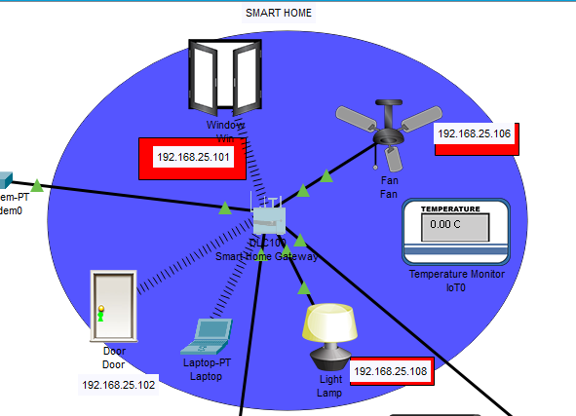

The above figure shows the smart object is connected to the home Gateway using Ethernet cable and wireless medium to manage smart device local and remotely. Home gateway also works as DHCP server by assigning IP address to each smart device that connected to it.

#### Smart phone:-

Through this device we can control and monitor the smart devices of the home remotely by logging into IOE server. We can set the algorithm or conditions in the IOE server through smart phone. Smartphone is connected through cell tower.

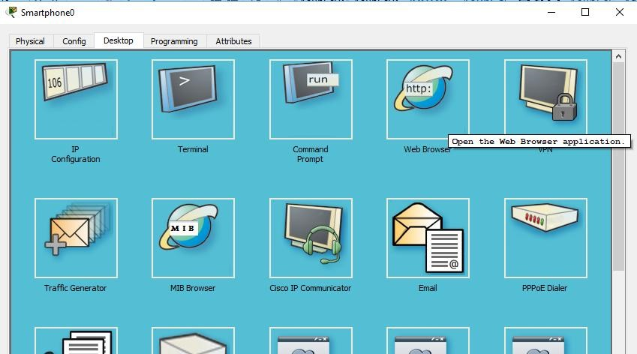

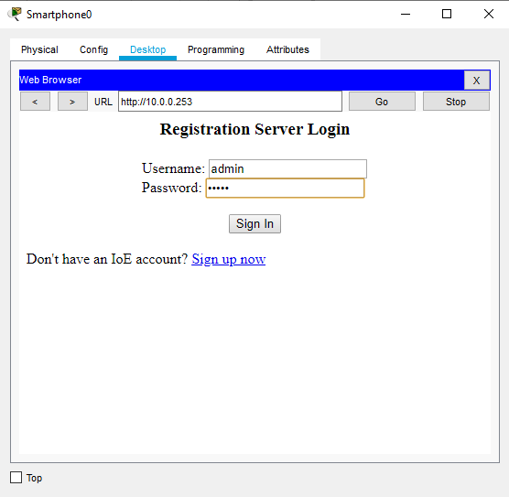

# MECHANISM AND WORKING:

**ISP Router Configuration**

Router>

Router>enable

Router#conf terminal

Router(config)#hostname ISP

ISP(config)#intgigabitEthernet 0/2

ISP(config-if)#ip address 10.10.220.1 255.255.255.0

ISP(config-if)#no shutdown

ISP(config)#intgigabitEthernet 0/0

ISP(config-if)#ip address 209.165.200.225 255.255.255.224

ISP(config-if)#no shutdown

ISP(config)#intgigabitEthernet 0/1

ISP(config-if)#ip address 209.165.201.225 255.255.255.224

ISP(config-if)#no shutdown

**Configurating dhcp server for cell and IOE device**

ISP(config)#ipdhcp excluded-address 209.165.201.225 209.165.201.230

ISP(config)#ipdhcp pool cell

ISP(dhcp-config)#network 209.165.201.225 255.255.255.224

ISP(dhcp-config)#default-router 209.165.201.225

ISP(dhcp-config)#dns-server 10.10.220.10

ISP(config)#ipdhcp excluded-address 209.165.200.225 209.165.200.230

ISP(config)#ipdhcp pool ioe

ISP(dhcp-config)#network 209.165.200.224 255.255.255.224

ISP(dhcp-config)#default-router 209.165.200.225

ISP(dhcp-config)#dns-server 10.10.220.10

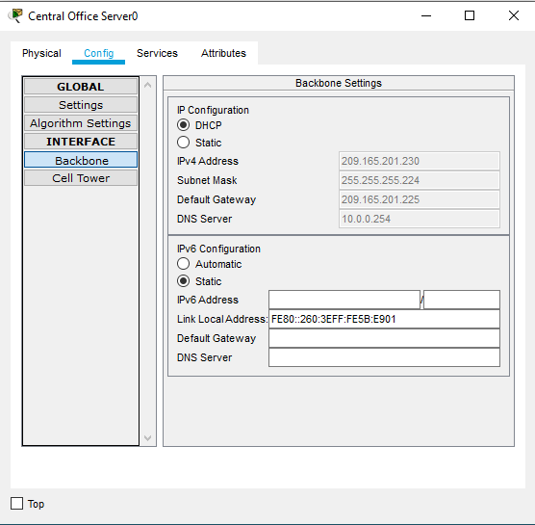

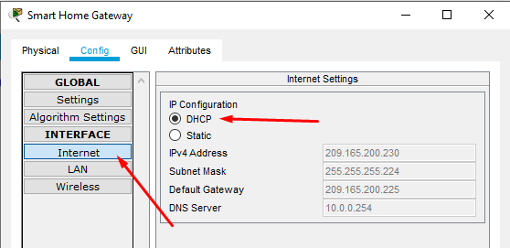

**Register all IOT devices in IOT server:**

click on the IOT devices->click on the config.->enter IOT server IP address, username, password. 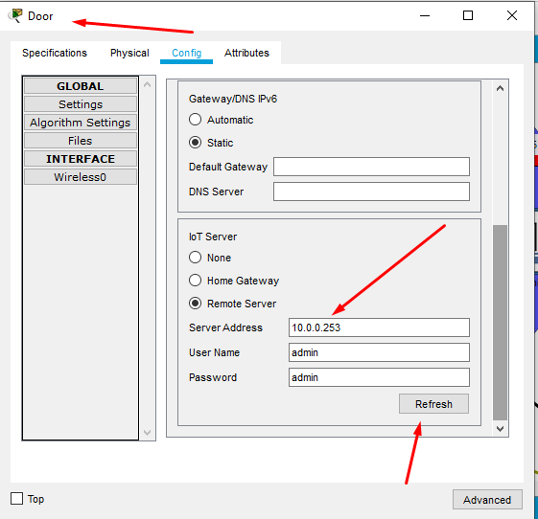

**Enable DNS services like HTTP, DNS etc.**

click on the DNS server->click on the sevice->enable different services like HTTP, DNS etc.

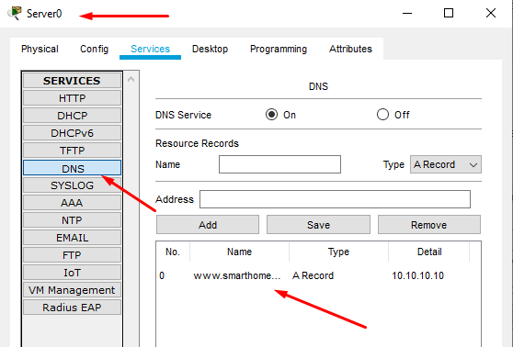

**Assign IP addresses to DNS and IOE server statically**

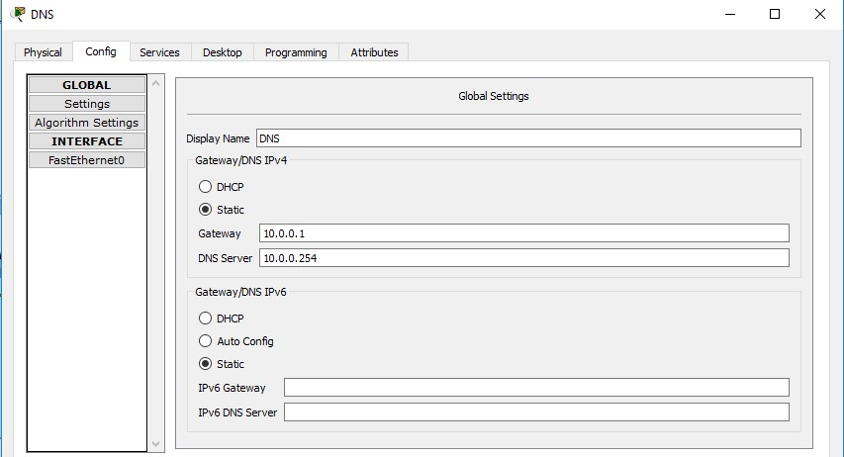

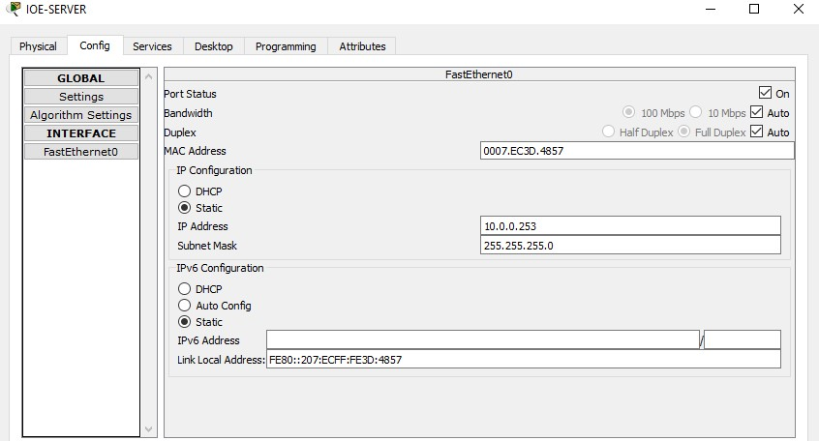

**Now control and monitor the IOE devices after logging into the IOE server from smart phone or PC.**

# FUNCTIONALITIES:

Explain the deliverables of the project considering DCN concepts and theories.

**Concepts of DCN covered in the project**

* ISP setting
* Configuring servers for remote device like laptop
* Connecting all home devices
* Home gateway with multiple smart-things connected
* IOE server that provide IOT functionalities
* IOT Functionalities

Output:

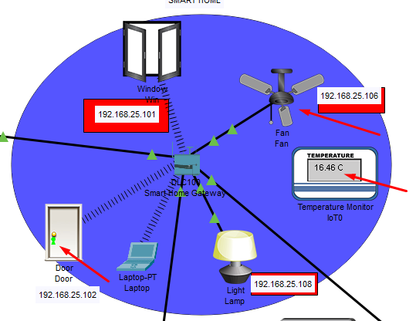

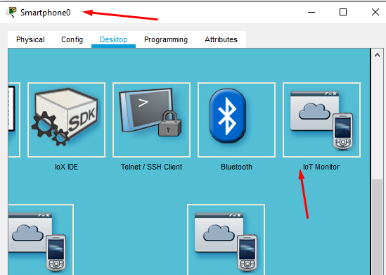

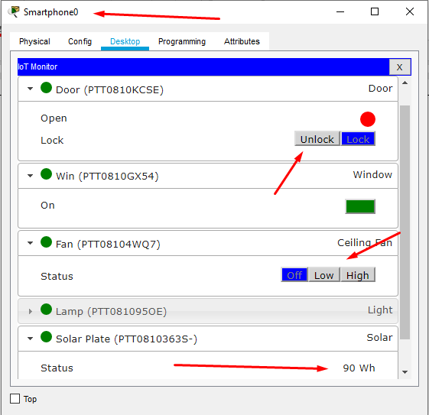

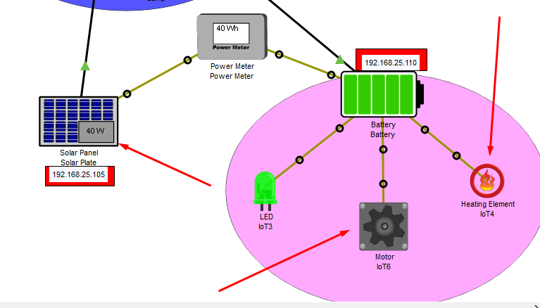

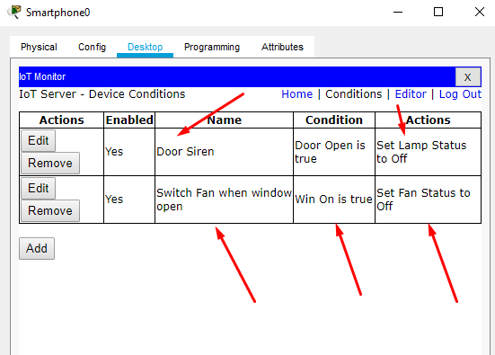

# FUTURE WORK:

Cisco packet tracer also includes microcontroller, that can be used to make communication between devices. We can use python or java script language to program the microcontroller. in this way if a microcontroller is used in the IOE system then work will be more faster and reliable.

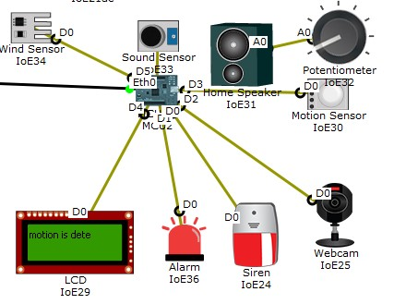

# CONCLUSION:

In building a smart home automated network we can simulate it using a Cisco package tracker and learn or know how to configure the network and connect multiple electronic devices to connect to each other over the wireless network, in addition, to set up some electronic devices based on their condition. set on smartphones With this simulation, design and implementation planning can be done in building smart home network using IoT home gate and there is a possibility that this simulation can be applied in real world based on current technology development, thus making it a necessity for community life which potency can improve energy efficiency , reducing energy use costs, controlling electronic devices and changing the role of occupants. we conclude that IoT has a great future and in the next five years, it is going to revolutionize the world. IoT is like clay that can be moulded in any way we wish, if provided with enough skills and expertise.

The home automation using Internet of Things has been experimentally proven to work satisfactorily by connecting simple appliances to it and the appliances were successfully controlled remotely through internet. The designed system not only monitors the sensor data, like temperature, gas, light, motion sensors, but also actuates a process according to the requirement, for example switching on the light when it gets dark. It also stores the sensor parameters in the webpage (database) in a timely manner. This will help the user to analyse the condition of various parameters in the home anytime anywhere.

# REFERENCES:

1. Chattoraj, Subhankar. "*Smart Home Automation based ondifferent sensors and Arduino as the mastercontroller.*" International Journal of Scientific and Research Publications5.10 (2015): 1-4.
2. Soliman, Moataz, et al. "*Smart home: Integrating internet of things with web services and cloud computing*." Cloud Computing Technology and Science (CloudCom), 2013 IEEE 5thInternational Conference on. Vol. 2.
3. S. Haller S. Karnouskos and C. Schroth "*The Internet of*

*Things in an Enterprise Context* " in Future Internet-FIS2008 Lecture Notes in Computer Science Vol. 5468 2009 pp 14-28.

1. Jie, Yin, et al. "*Smart home system based on iot technologies*." Computational and Information Sciences (ICCIS), 2013 Fifth International Conference on. IEEE.